|  |
| --- |
| Fortum/VTT |
| **Apros 6 Nuclear exercises** |
|  |
|  |
| **Sixten Norrman** |
| **Ver 9.9.2013** |

|  |
| --- |
|  |

*This page is intentionally left blank.*

# Contents

Contents ii

Introduction 2

Exercise 1 – Simple PWR Containment model 3

Task 1 – Running independent containment analyses 4

Task 2 – Running integrated containment analyses 10

Exercise 2 – Generic VVER-440 model 15

Excercises with the model comprise the following tasks 15

Task 1 – Navigating in the model 16

Task 2 – Running a transient 18

Task 3 – Running a small break LOCA (SBLOCA) -1 19

Task 4 – Running a small break LOCA (SBLOCA) -2 22

Task 5 – Running a primary-to-secondary-side leak (PRISE) 23

Task 5 – Running a 200 % steam line break 26

*This page is intentionally left blank.*

# Introduction

This document contains Exercise sessions for the course Apros Training Course – Nuclear Features.

The main idea is to learn how to define disturbance and faults in the model causing transient and accident scenarios. The purpose is that the user should learn typical ways of performing safety analyses and to learn how to analyze the model behavior. In the first exercise a simple containment model will be created, in the second exercise a ready-made model will be used.

It is good practice to save a good initial condition and to export the model after the scenarios have been defined prior to the transient simulation starts.

# Exercise 1 – Simple PWR Containment model

A simple containment model will be created in two Tasks. The model will include only two containment nodes describing the lower compartments of a PWR-plant. Real containment analyses models are of course much more complex. Containment analyses can be done both independently and in an integrated way, i.e., the containment model is coupled to a plant model. In the following tasks both ways of performing analyses are practiced.

The model has two diagrams, a process diagram and a control diagram, an overview of the model is seen in the following two figures. Please follow the more detailed modeling instruction in the following sections.

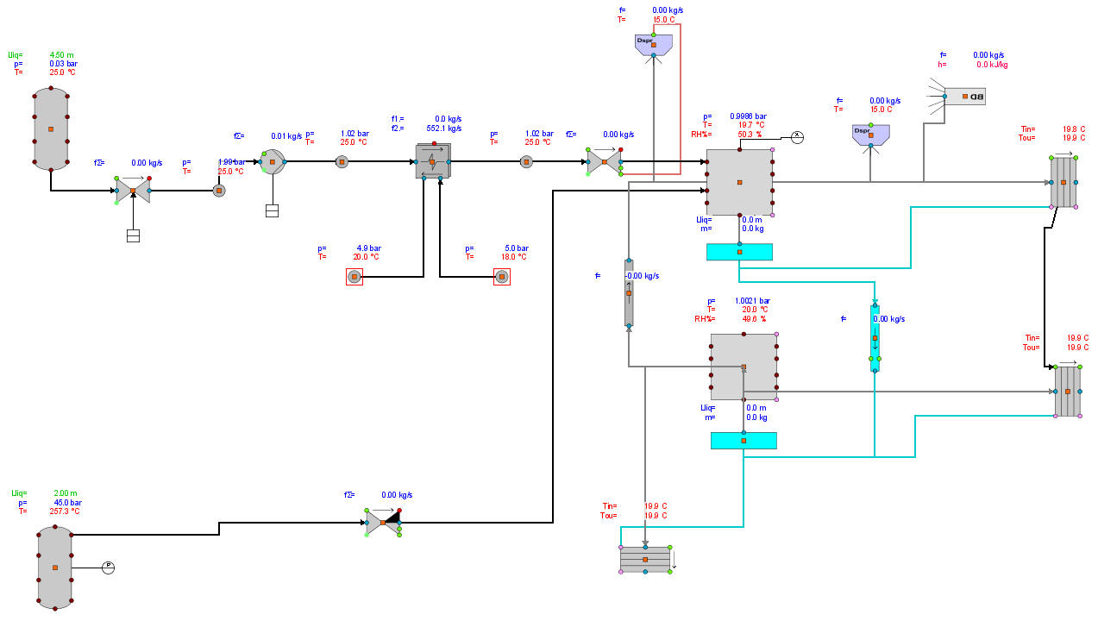

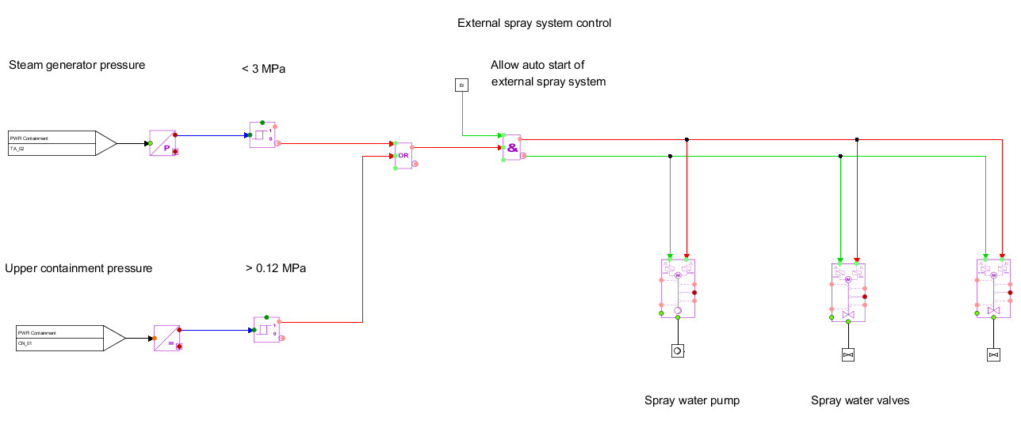

## Task 1 – Modelling the containment and running independent containment analyses

For LOCA- (Loss of Coolant Accident) analyses the break mass flow and enthalpy curves and the spray water mass flow and temperature curves are usually known or they are achieved from thermal hydraulic analyses. When the containment model is not integrated to the plant model the break and spray curves as a function of time can be given to Blowdown- and Internal Spray modules in order to analyze the containment response in the accident case. Task 1 gives an example on how this can be done.

### Create the containment nodalization

First we have to create the containment part of the model

1. Create a new model and rename it to “PWR Cont example”.
2. Create a new Process Diagram and rename it to “PWR Containment”.
3. Open the diagram.
4. DnD symbols from the CON Containment symbol library to the diagram, connect the symbols and give initial values according to the figure below. Use profiles Dimensioning 1, Dimensioning 2, Simulated 1

***Note!*** *Containment components (gas branch, water branch, sump, blowdown, spray etc. – blue terminals) are connected to the center of the containment nodes.*

***Note!*** *Pressure and temperature are given and show in bar and ˚C in the monitor profiles while they must be given and are shown in SI units Pa and K in the property window.*

***Note!*** *Values of containment node parameters Elevation top, Elevation bottom and Floor area are calculated values*

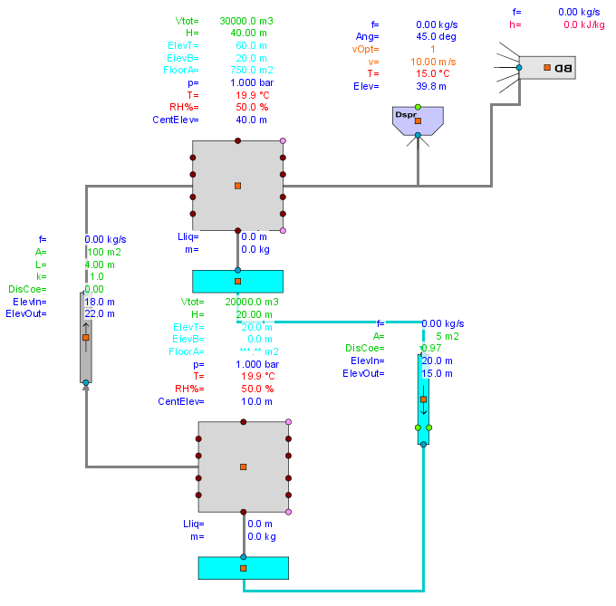

1. All necessary properties are not defined in profile monitors. For both Containment Node components define the noncondensable gases and their mole fractions in the property view. Open the property view and filter with string “noncond”.

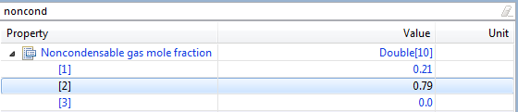

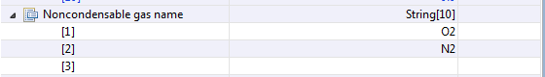



1. Open the properties for the internal spray component and modify the following parameters



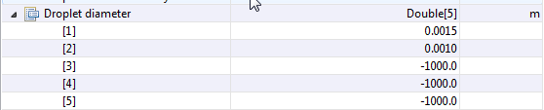

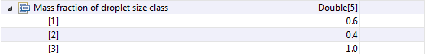

1. Dnd three heat structures from the CON Containment Process Components library. Connect them to the center of the containment nodes and give parameters as specified in the figure on the next page. Use profile monitors Dimensioning 1, Dimensioning 2 and Dimensioning 3.
2. Connect the upper vertical heat structure to the lower vertical heat structure in order to allow condensate flow from the upper to the lower structure. All condensed water is directed from the lower heat structure to the lower node sump.

***Tip****. With the mouse on the upper vertical heat structure open the menu list with mouse button-2 and select Attached Connection Routing → Direct*

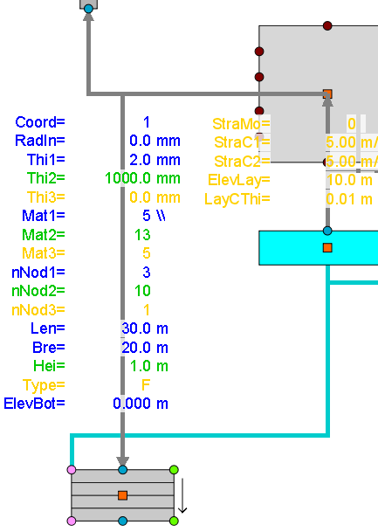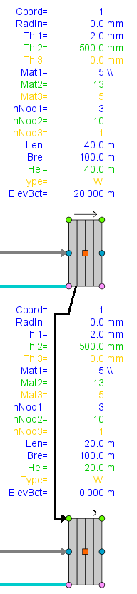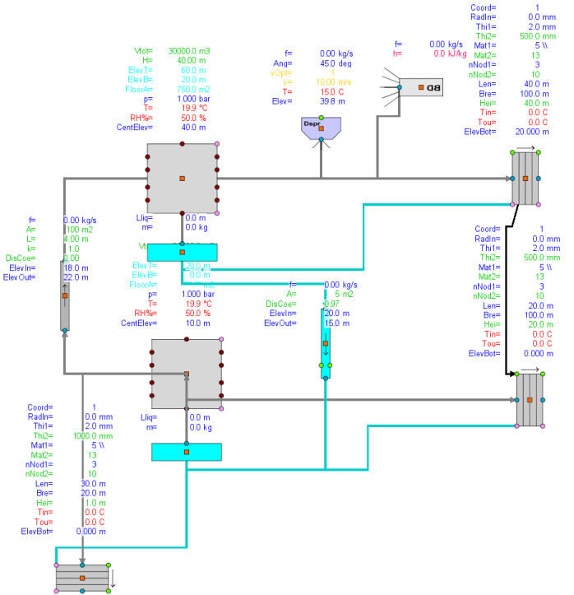

1. Add a chart with Containment pressure and temperature and also blowdown and spray mass flows.

***Note!*** *If the pressure (bar) and temperature (˚C) profile monitors are dragged to the chart, they will show up in units Pascal and Kelvin in the chart. In the chart variable property window it is possible to scale the parameters to units bar and ˚C .*

1. Simulate forward one minute to see if everything is OK. Save IC with the option to reset the time to 0.0 s

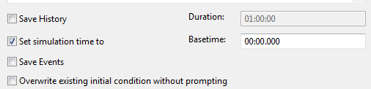

1. Load the IC that was created in the previous step. The time in now reset to 0.0 s.

### Specify boundary conditions for break and spray calculation

1. Specify a time dependent break mass flow curve for the blowdown component as shown below. In order to see the curve, open the property view for the blowdown component and double click in the value column of the “Table values”. The table values appear in a new window. Select Apply after the values have been given.

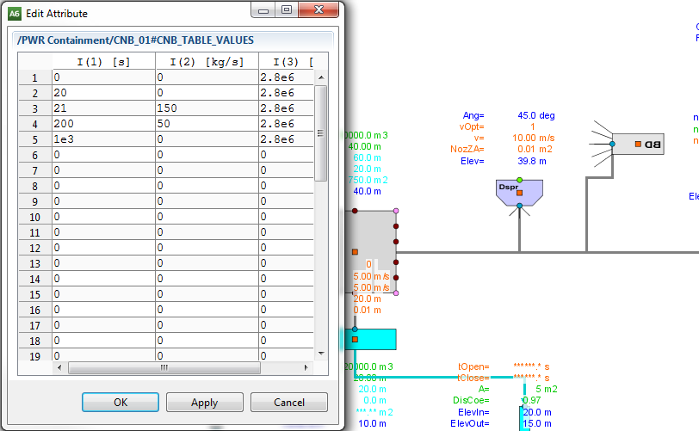

1. In a similar way define a spray mass flow rate and temperature curve to the internal spray module on the right side of the upper node. Double click in the value column of parameter “Table values” in Property view. Note that the temperature is given in [K], the profile monitor shows the temperature in [˚C].

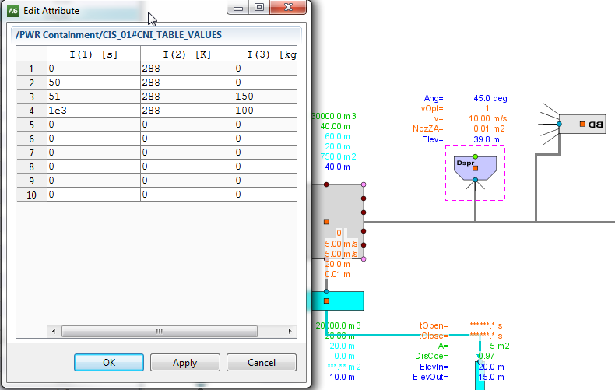

1. Save IC with the option “Set the simulation time to Basetime 0.000” selected. Export the model.
2. The accident will start at time 20 s and the spray is initiated at time 50 s. In order to take the time dependent sources into operation define the following parameters in the blowdown and the spray components:

Blowdown component:



Spray component:



Open the predefined charts and start the calculation.

***Note!*** *If the IC is loaded after the transient has been run the blowdown and spray injection activation attributes are still True. If you want to continue to develop the model or run steady-state these attributes must be defined to be False in order to prevent the transient phase to be initiated.*

*Blowdown component:*

**

*Spray component:*



## Task 2 – Running integrated containment analyses

In this task the process of a plant model in terms of a spray line and a connection to a steam source representing a steam line break are added to the model. A simple automation system is added in order to initialize the steam line break and the spray circuit.

### Preparations for the thermal hydraulic part

1. Import the model that was exported in step 14 of the previous task. Make sure that the blowdown and sprays are not activated

***Note!*** *If only the IC is loaded after the transient of Task 1 has been run, the blowdown and spray components must be deactivated (see notification after step 15 in the previous Task). The status of these parameters are not stored in the IC when it is saved.*

1. In order to be able to connect thermal hydraulic systems to containment nodes the elevation of terminals to which the connection lines will be connected has to be defined in the containment node. The external spray line and the steam line will be connected to the upper node. Define for this node the following elevations for terminals 1 and 3:

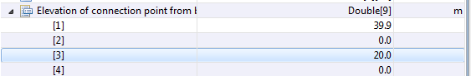

### Modelling the spray and steam lines

1. Model the spray- and steam lines according to the figure and tables below. Use profiles Dimensioning 1, Dimensioning2, Simulated 1, Solver 1 and Not in simulation.

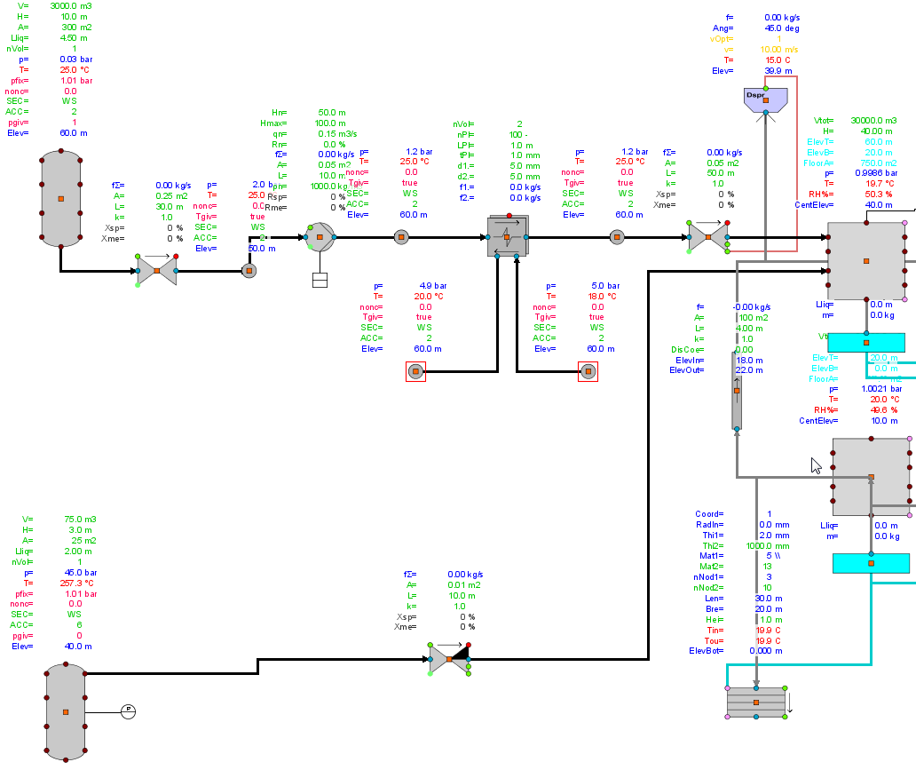

**Spray line, flow model 2**

|  |  |  |
| --- | --- | --- |
| Spray line Tank | Area | 300 m2 |
|  | Height | 10 m |
|  | Liquid level | 4.5 m |
|  | Temperature | 25 C |
|  | Elevation | 60 m |
|  | Is fixed pressure used | 1 |
|  | Fixed pressure | 1.013 bar |
|  | Calculation of material properties | 2 |
|  |  |  |
| Shut-off valve after tank | Length | 30 m |
|  | Area | 0.25 m2 |
|  | Treatment of closed valve | 2 |
|  | Leak position | 0.0001 |
|  | Position | 0.0 |
|  | Position set point | 0.0 |
|  |  |  |
| Point after valve | Elevation | 50 |
|  | Pressure | 2 bar |
|  | Temperature | 25 C |
|  |  |  |
| Basic pump | Length | 1.0 m |
|  | Area | 0.05 |
|  | Nominal volum.flow | 0.15 m3/s |
|  | Nominal density | 1000 kg/m3 |
|  | Nominal head | 50 m |
|  | Maximum head | 100 m |
|  | Nominal rotation speed | 100 % |
|  | Rotation speed | 0.0 % |
|  | Speed set point | 0.0 % |
|  |  |  |
| Point after pump | Elevation | 60 |
|  | Pressure | 1.2 bar |
|  | Temperature | 25 C |
|  |  |  |
| Heat exchanger (counter-current plate) | Number of calc nodes | 2 |
|  | Is heat transferred to connection points | F |
|  |  |  |
| Point after heat exchanger | Elevation | 60 |
|  | Pressure | 1.2 bar |
|  | Temperature | 25 C |
|  |  |  |
| Shut-off valve before cont node (TH-CONT) | Length | 50 m |
|  | Area | 0.05 m2 |
|  | Treatment of closed valve | 2 |
|  | Leak position | 0.0001 |
|  | Position and pos set point | 0.0 |
|  | **Spray calculation** | **1** |
|  |  |  |
| Spray | Elevation from node bottom | 39.8 m |
|  | Temperature | 25 C (298 K) |
|  | Spray velocity option | 1 |
|  | Initial velocity | 10 m/s |
|  | Inner time step | 2 s |
|  | Number of droplet size classes | 2 |
|  | Droplet diameter(1) | 0.0015 m |
|  | Droplet diameter(2) | 0.0010 m |
|  | Mass frac of droplet size(1) | 0.6 |
|  | Mass frac of droplet size(2) | 0.4 |
|  |  |  |
| Heat exchanger sec side, inlet point (not in simulation) | Elevation | 60 |
|  | Pressure | 5.0 bar |
|  | Temperature | 18 C |
|  |  |  |
| Heat exchanger sec side, outlet point (not in simulation) | Elevation | 60 |
|  | Pressure | 4.9 bar |
|  | Temperature | 20 C |

**Steam line, flow model 6**

|  |  |  |
| --- | --- | --- |
| Steam Tank | Area | 25 m2 |
|  | Height | 3 m |
|  | Liquid level | 2 m |
|  | Pressure | 45 bar |
|  | Elevation | 40 m |
|  | Is fixed pressure used | 0 |
|  |  |  |
| Basic valve before cont node (TH-CONT) | Length | 10 m |
|  | Area | 0.01 m2 |
|  | Position | 0.0 |
|  | Position set point | 0.0 |

1. Save IC and export the model.

### Modelling an automation system

In order to activate the external spray process system a simple control system is modeled.

1. Add a new Automation diagram, rename it to “Control”.
2. Add automation components as shown in the following picture. Connect the steam tank to the pressure measurement and the upper containment node to the general measurement. Measure the tank and the containment node pressure in MPa.
3. Add an actuator of type” A13: On-off pumps (pulse)” and connect it the basic pump in the process diagram. Add two actuators of type “A03: Motor shut-off valves” and connect them to the shut-off valves in the spray line in the process diagram.



1. The spray line pump is started and the valves are opened when either the pressure in the upper containment node exceeds 0.12 MPa or the pressure in the steam source tank decreases below 3 MPa (initially 4.5 MPa). Additionally the control system must be allowed to operate by changing the external binary signal “Allow_start_sign” from False to True.
2. Save IC and export the model.
3. Run steady state first for a about 20 s. The accident is initiated by opening the basic valve(Position set point of valve 1.0 or profile Xsp to 100 %) in the steam line.

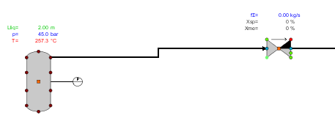

# Exercise 2 – Generic VVER-440 model

The simulation model is this exercise is a complete nuclear power plant model with a VVER-440 type of a pressurized water reactor. The model includes all main process components and their control automation devices. Some of the less important systems are simplified or not modelled at all. For example, the make-up water is injected by opening valves connected to a point with constant 135 bar pressure, the injection pumps are not modelled. The sea water cooling water pumps of the condenser are also not included in the model and cooling water flow through the condensers is maintained by an artificial pressure difference in the cooling water line. Further, the plant containment is not included in the model.

The simulation model contains over 50 diagrams (or pictures), most of them are process and automation diagrams. For the thermal hydraulic process modelling the 6-equation model is used in the primary circuit and the 3-equation model in the secondary circuit. The reactor core is modelled with a one-dimensional neutronics model, which has two energy groups and six delayed neutron groups. Values for some of the most important plant parameters at steady state operation are listed in table 1.

Table 1, Plant main parameters at steady state.

|  |  |
| --- | --- |
| **Parameter** | **Value** |
| Reactor thermal power | 1380 MW |
| Produced net electricity | 465 MW |
| Ppressure in pressurizer | 123 bar |
| Pressurizer water level | 5.3 m |
| Primary circuit coolant flow | 6 * 1426 kg/s |
| Secondary circuit pressure | 44 bar |
| Core inlet temperature | 264.7 °C |
| Core outlet temperature | 295.6 °C |

### Excercises with the model comprise the following tasks

1. Learn to navigate in the model and find parameter values and control concepts.
2. Run a simple transient
3. Define a small break LOCA (Loss of Coolant Accident) and run the accident scenario
4. Define a PRISE-leak (Primary-to-Secondary-side leak) and run the accident scenario
5. Define a steam line break and run the accident scenario

## Task 1 – Navigating in the model

In order to familiarize yourself with the model you are asked to navigate in the model and find answers to a couple of questions.

Navigating in the model can basically be done in three ways:

* Jump from a reference flag of a component by double clicking the flag. If there are several reference flags from a component then one with a descriptive name for the other diagram should be or selected
* Select a diagram from the Configuration directory in the Model browser
* If the name of the component that is searched for is known then the name can be given in the search field at the bottom right corner.

To find values of certain properties of components either the Profile monitors or the Property view can be used.

Questions:

1. What is the water level in the steam generator secondary side in loop 1 (YB11W001)?

_________________________________________________________________

1. What is the pressure at the inlet of the turbine control valve of steam turbine SA10 (turbine_10)?

_________________________________________________________________

1. What is the feed water temperature at the steam generator inlet?

_________________________________________________________________

1. What is the temperature of the water in hydroaccumulators TH41B001, TH42B001, TH81B001 and TH82B001?

_________________________________________________________________

1. What is the boron concentration in the primary circuit? _________________________________________________________________
2. What is the boron concentration in the emergency water injection tank TH00B001?

_________________________________________________________________

1. How many nodes is the pressurizer divided into?

_________________________________________________________________

1. How is the steam generator level controlled?

_________________________________________________________________

_________________________________________________________________

_________________________________________________________________

1. How is the pressurizer pressure controlled?

_________________________________________________________________

_________________________________________________________________

_________________________________________________________________

## Task 2 – Running a transient

In this exercise you will learn how to make changes in the model in order to run transients. As a first step one main coolant circulation pump in the primary side is stopped and after a while one of the two parallel turbines is tripped manually. Do the exercise in the following order and answer the questions:

1. Describe shortly what you expect to happen in the primary side and in the secondary side when one pump is stopped.

_________________________________________________________________

_________________________________________________________________

1. Open the Chart window and run steady state for ca 20 s.
2. Stop the main circulation pump YD11D001 in loop 1. *Tip:* The main circulation pumps are connected to the protection system via a device controller. It is possible to stop the pump from the device controller.
3. Start the calculation and run for about two minutes.
4. Look at the Chart curves and the monitors in picture "primary/primary" and check if the expectations on the plant response in step 1 are correct.

_________________________________________________________________

1. The next step is to stop one turbine. Describe shortly what you expect to happen in the primary and secondary sides.

_________________________________________________________________

_________________________________________________________________

_________________________________________________________________

1. Trip turbine SA10. In order to do so go to picture "Protection_aut/rea_tur_trip" and locate a binary signal causing a manual trip of the turbine.
2. Start the calculation and run for about 3 minutes.
3. Look at the Chart curves and the monitors in pictures "primary/primary" and "secondary/steam_gen" and check if the expectations on the plant response in step 6 are correct.

## Task 3 – Running a small break LOCA (SBLOCA) -1

In this exercise you will learn how to add new components to the model, how to add conservatism for the accident scenario and how to run an accident. A small break is added to one cold leg in the primary side. One accumulator and one high and one low pressure emergency injection pump are assumed not to function. Do the exercise in the following order and answer the questions:

1. Describe shortly what you expect to happen in the accident scenario

_________________________________________________________________

_________________________________________________________________

_________________________________________________________________

1. Import a fresh version of the model (File →Import →Apros6 Model …… VVER1375_6eq_1D).
2. Open picture “primary/emergency” and modify attribute “Malfunction” to 2 for pump TH11D001 (low pressure injection pump) and TJ11D001 (high pressure injection pump). This means that these pumps fail to start on an automatic start signal.
3. Prevent ECC accumulator TH41B001 from emptying when the primary side pressure decreases. This can be done by excluding the discharge pipe closest to the accumulator

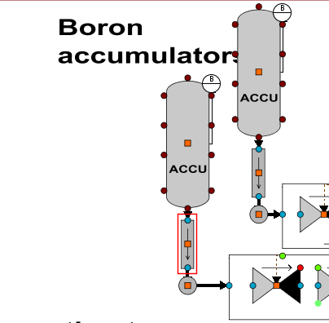

1. Open picture “primary/primary” and add a point and a valve to cold leg 1. The point shall be excluded from the simulation in order to form a pressure boundary condition for the break, the valve represents the break. The following parameters shall be given to the components:

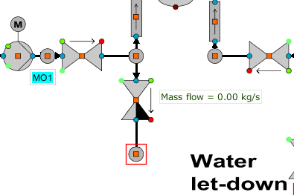

Boundary point:

Elevation from ref. level: 11.75 m

Flow model: 6

Name of fluid: WSB

Pressure: 0.1 MPa

Void fraction: 1.0

Basic valve name: BRKVLV_YA11

Flow length of valve: 2.0 m

Flow area: 0.01 m2

Form loss coeff: 1.0

Position setpoint of vlv 0.0

Driving time of valve: 1.0 s

1. Connect the valve with the primary loop point and the break pressure boundary point. Add a monitor for the mass flow in order to see the current mass flow. Also add a new Chart window and select both the liquid and steam mass flow rates to be plotted in the Chart.
2. Additionally specify critical flow calculation to be accounted for in the break branch. To do so

* go to the Model browser and navigate to Configuration → Exeptions → TH6_CONTROL_EXCEPTION
* Add a new TH6_CONTROL_EXCEPTION with mouse button-2 and select New → Component.
* Open the new exception component and add the name of the break valve branch to the first index of the item Branch with critical flow check

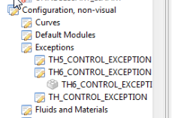

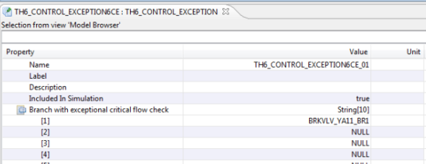

1. Save the initial condition and export the model, e.g with name vver1375_6eq_sbloca).
2. Open the chart windows and run steady state for about 20 s.
3. Open the break valve by modifying parameter “Position set point of valve” from 0 to 1.
4. Start the calculation and run a few seconds **until reactor scram occurs**, i.e keep an eye on the Chart window where the reactor power is – a reactor scram occurs when the power starts to decrease rapidly. Open picture "protection_aut/rea_tur_trip" and check which signals and conditions have caused reactor scram by selecting Binary signal coloring from the Profile list.

_________________________________________________________________

_________________________________________________________________

_________________________________________________________________

1. Continue to run the accident scenario.
2. Look at the trend curves and check if the expectations on the plant response in step 1 are correct.

## Task 4 – Running a small break LOCA (SBLOCA) -2

In this exercise the same SBLOCA accident will be run from a command que-file, the calculation results will be exported to a datafile. Analyses cases are usually run from a command file in order to be able to repeat the run in exactly the same way several times – e.g. when running comaprisons with different program or model versions or when performing parameter variations.

1. Import the SBLOCA-model that was exported in the previous task in step 8.
2. In the Model browser add a new que-file under folder Queues. Rename the file to run_vver1375_sbloca1. Write the following commands. Be careful that the name of the break valve is the same as the name of the valve you added in your model.

echo

echo Running SBLOCA in cold leg YA11, vver1375

echo

!

! reset simulation time

modi ecco simulation_current_time 0

!

!run steadystate

do 20

!

! open break and run 15 min (900 s)

modi brkvlv_ya11 va11_position_set_point 1.0

do 900.0

1. Run the SBLOCA-case from the command que (Mouse-2 button -> Run)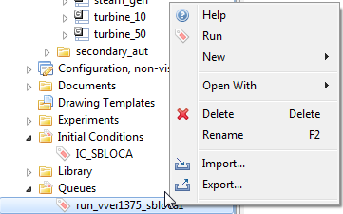
2. Wait until the simulation has stopped. Export the subscriptions to a csv-file and import it to Excel where you can plot the curves if desired.

## Task 5 – Running a primary-to-secondary-side leak (PRISE)

In this exercise a primary-to-secondary side leak (PRISE) will be calculated. Two leak paths will be added between calculation level nodes belonging to the primary and the secondary sides of steam generator YB11W001. As the steam generator component creates several calculation level components the correct nodes to connect must be found out.

The number of nodes created depends on the following parameters given in the steam generator process component.

|  |  |
| --- | --- |
| **Parameter** | **Input value** |
| Is collector divided into several nodes | T |
| Number of calculation nodes inside the tube | 5 |
| Number of generated downcomer lines | 1 |
| Number of calculation nodes in the heater | 5 |
| Is heater divided horizontally | F |
| Number of calculation nodes in the steam dome | 2 |

1. To find out how many nodes belong to the primary and secondary side respectively give the command ”get no6_pressure” in the Apros console window. This command lists all the pressure values [Pa] of the 6-equation nodes.
2. Scroll up until YB11W001_NOXX nodes are listed. For YB11W001-nodes note what is the first node number with secondary side pressure (secondary side pressure, 45 bar < primary side pressure 122 bar) and what is the total number of YB11W001-nodes.

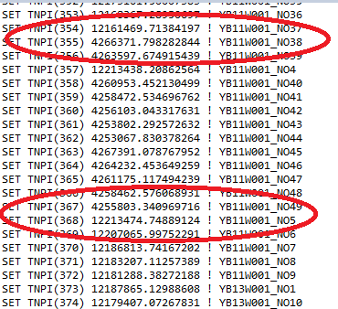

1. In this case primary side nodes span from _NO1 to _NO37 and secondary side nodes from _NO38 to _NO49, the distribution is shown in the figure below.

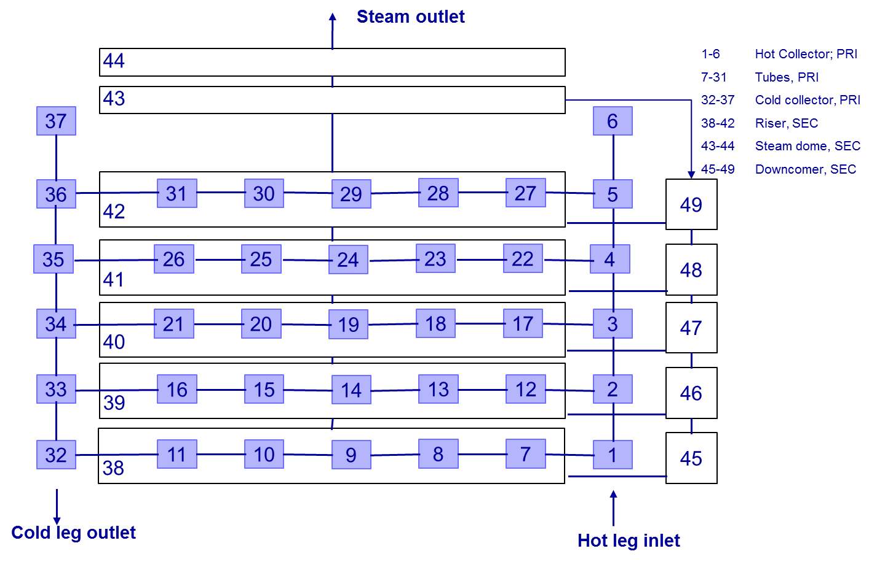

1. Two leak paths simulating a rupture of five tubes (diam of one tube is 13.2 mm → A(5 tubes) = 6.842e-4 m2/ leak) at bottom of the cold collector to the lowest riser node in the secondary side will be added
2. Drag from the Model browser calculation level nodes YB11W001_NO11, YB11W001_NO32 (primary side) and node YB11W001_NO38 (secondary side) to diagram “primary” next to steam generator YB11W001. Add two leak pipe PRISE_LEAK1 and PRISE_LEAK2 between each primary side node and the secondary side node to simulate a leak from both sides of the tube. Add a TH6_CONTROL_EXCEPTION-module where critical flow is defined for the leak branches in the same way that was used in Task 3, Step 7.

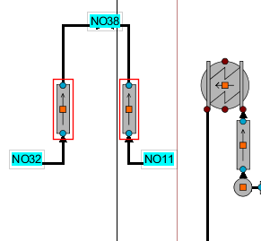

Leak pipe parameters

Flow length: 0.5 m

Flow area: 0.0006842 m2

Hydraulic diam. 0.0132 m

Loss coeff: 1.0

1. Select parameters to follow in a chart.
2. Exclude the pipes from simulation, otherwise the leak will start from the beginning of the calculation.
3. Save the IC and export the model.
4. Run steady state for a moment. The accident starts when the leak pipes are included in simulation.

## Task 5 – Running a 200 % steam line break

With the experience from previous Tasks add a guillotine break (200 % break) to steam line 1 according to the figure below.

The break valve area should be equal to the steam line area. A valve should replace the pipe component between the break valves and this valve should close when the break valves open. Additionally the replacement valve should have identical configuration parameters (area, length, flow loss coefficient) as the original pipe. Remember to define critical flow for the break valve branches.

